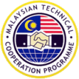

MALAYSIAN TECHNICAL
COPERATION PROGRAMME 2016

CBRNE - FIRST RESPONDER
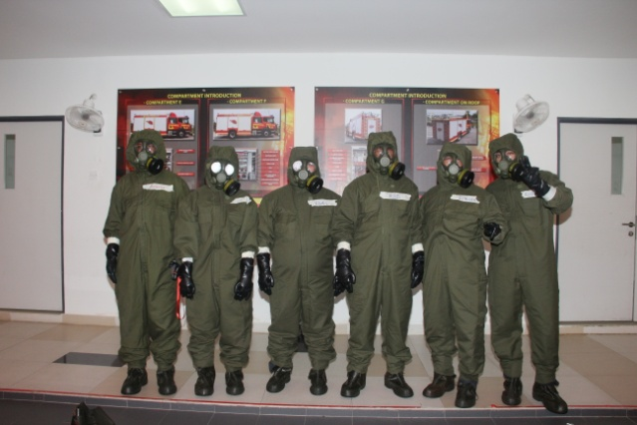
TRAINING PROGRAMME

26 July – 5 August 2016
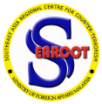
Organised by:

Southeast Asia Regional Centre for
Counter-Terrorism (SEARCCT)
ABOUT MTCP:
The Malaysian Technical Cooperation Programme (MTCP) was first initiated at the First Commonwealth Heads of Government Meeting (CHOGM) for Asia Pacific Region in Sydney in February 1978. It was officially launched on 7 September 1980 at the Commonwealth Heads of State Meeting in New Delhi to signify Malaysia’s commitment to South-South Cooperation, in particular Technical Cooperation among Developing Countries (TCDC). In line with the spirit of South-South Cooperation, Malaysia - through the MTCP - shares its development experiences and expertise with other developing countries. Initially formulated based on the belief that the development of a country depends on the quality of its human resources, MTCP emphasizes the development of human resources through the provision of training in various areas essential for a country’s development. To date, MTCP has extended its recipient of countries to more than 141 developing nations for training within its ten (10) key areas. Since its inception, more than 30,686 participants from more than 141 recipient countries have been directly trained under MTCP.

OBJECTIVES OF MTCP
• To share Malaysia’s development experience with other countries;
• To strengthen bilateral relations between Malaysia and other developing countries;
• To promote South-South cooperation (SSC); and Technical cooperation among developing countries
• To promote technical cooperation among developing countries (TCDC)
ABOUT SEARCCT:
Established on 1 July 2003, the Southeast Asia Regional Centre for Counter-Terrorism (SEARCCT). The Centre’s aim is to conduct research, capacity-building and public awareness programmes in countering terrorism. Since its inception, SEARCCT has held various types of training courses, seminars, workshops, conferences, and forums, in collaboration with numerous countries, under seven (7) core areas, which are:
- Investigation and Legal Aspects;
- Chemical, Biological, Radiological, Nuclear and Explosive (CBRNE) and Crisis Management;
- Aviation, Maritime and Transportation Security;
- Cyber Terrorism;
- Prevention and Rehabilitation;
- Terrorism Financing; and
- Youth and Terrorism.

SEARCCT conducts research activities in terrorism and counter-terrorism related issues such as Aviation Security, Youth and Terrorism, Internet Radicalisation and Cyber Security via field-work and academic exercises. The Centre has also published articles and monographs, and is actively involved in delivering papers and lectures at the local, regional and international level.
SEMINAR BACKGROUND:
Terrorist groups have shown interest in acquiring CBRNE agents for their operations. This training programme will identify and expose the various methods and response when dealing with a CBRNE threat.
COURSE CONTENTS:
The programme will define a CBRNE terrorist incident and discuss the likely targets of terrorist attack. Moreover, the programme will present the type and characteristics of various CBRNE agents and its effect. The response structure in dealing with such threats will also be discussed.
COURSE OBJECTIVES:
- To provide the participants with the knowledge and understanding on the trends of terrorists utilising CBRNE agents;
- To prepare first responders to plan and respond to a CBRNE incidents;
- To provide the participants with an avenue to exchange views, experience and possible solutions on how best to address the issue; and
- To provide the participants with the necessary tools to recommend to their respective governments on how to deal with CBRNE threats.

COURSE METHODOLOGY:
The programme will provide a series of lectures, group discussions and study visits. Representatives from each respective country will be required to present a 10-minute Country Report on the mechanism and practices in dealing with the CBRNE threat. The presentation should include the issues and responses of the country in handling the CBRNE threat.

WHO SHOULD ATTEND?
This programme is offered to junior to mid-level officials who are involved in either one of the following:
- First Responders: Officials from:
- Fire and Rescue.
- Medical Services.
- Law Enforcement: Law enforcement officials with knowledge and background in:
- Counter-terrorism.
- CBRNE Crisis Management.
- Forensic Investigation.
To be eligible to apply, applicants of the course are obliged to fulfil the following requirements:
- Must be between the ages of 26 – 46 years at the commencement of the course;
- Must possess a university degree;
- Fluency in both spoken and written English;
- Medically fit (applicants must submit his/her medical report together with the application form).
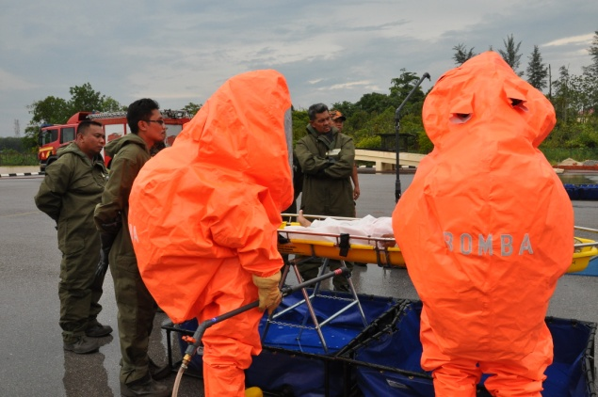
MEDIUM OF INSTRUCTION
This course will be fully conducted in English. Therefore, participants are required to have an appropriate level of proficiency in the English language, written as well as spoken.
ACCOMMODATION:
Accommodation will be provided throughout the duration of the training by the organiser.
COURSE DURATION: 26 July – 5 August 2016
APPLICATION PROCEDURE - HOW TO APPLY:
All applications should be made in the prescribed forms available at http://mtcpcoms.kln.gov.my/mtcpcoms/online/list_course
Application forms must be complete, and endorsed by the Ministry of Foreign Affairs/ Focal Point (responsible for the MTCP Programme) in the applicant’s respective country. Subsequently, three (3) copies of the completed application forms must be submitted to the Malaysian Embassy/High Commission via Note Verbale at the respective applicant’s country. Submitted application form must be accompanied by the candidate’s copy of passport/colour copy of passport, current passport size coloured photo and medical record.
For Course Information and Application Guidelines, please refer to the following link: http://mtcpcoms.kln.gov.my/mtcpcoms/online/list_course
INCOMPLETE/OR UNENDORSED FORMS WILL NOT BE PROCESSED.

AIR FARE:
A return air ticket from the capital city of the recipient’s country to Kuala Lumpur on economy class will be provided by the Government of Malaysia to selected participants from recipient countries with GDP per capita below USD 5,000. Therefore, some MTCP recipient countries may need to bear their own air fares. Tickets will be issued upon confirmation of acceptance.

VISA & VACCINATION:

It is mandatory that all MTCP participants adhere to the Visa With Reference (VWR) application procedure to enter Malaysia. Person seeking to enter Malaysia must be in possession of valid passport or other internationally recognized travel document and visa if required. Participants should ensure that their Passport or other travel document must be valid for at least 6 months beyond the period of stay allowed in Malaysia
Upon receiving the colour copy of passport, current passport size coloured photo and acceptance letter from the selected participants, successful participants are required to submit a coloured photocopy of the first page of their valid passport to the Training Institution/programme organizer who will apply for VWR at the Department of Immigration in Malaysia for immigration processing and obtaining specific VWR Approval Letter for the participants.
Upon approval, a copy of this VWR Approval Letter will be forwarded to the participants who will subsequently need to collect their respective VWR from the nearest Malaysian Mission. Participants who receive the specific VWR Approval Letter are required to obtain a VWR stamp at the specified Malaysian Mission before entering Malaysia.

NOTE: Successful participants must arrange for their own visa and vaccination prior to their travel. Expenditures on all visa-related fees, airport-tax/airport user’s charge, transit insurance, excess luggage, travel tax, transit fees, domestic passenger terminal fees, phone chargers, private purchases, etc. are BORNE BY THE PARTICIPANTS. This also applies for medical check-up vaccinations prior to travel to Malaysia;
Participants from yellow fever endemic areas including diplomatic and official passport holders are required to take a mandatory vaccination for yellow fever at least ten (10) days prior to their departure to Malaysia and required to produce a Yellow fever Vaccination Certificate at the entry point in Malaysia.

NOTIFICATION:
- Applicants who do not receive notification prior to the commencement of the course can assume their applications have been deemed unsuccessful.
- No written notification will be sent to unsuccessful applicants.

CLOSING DATE FOR APPLICATION: 7 MAY 2016

COURSE COORDINATOR: Captain Mohd Ajlan Bin Ramli
ADDRESS: Southeast Asia Regional Centre for Counter-Terrorism (SEARCCT), Ministry of Foreign Affairs, Malaysia. No. 516, Persiaran Tuanku Jaafar, Bukit Persekutuan, 50480 Kuala Lumpur, Malaysia

PHONE NUMBER: (6)03 22742025 (Captain Mohd Ajlan) FAX : (6) 03 22737246
EMAIL : ajlan@searcct.gov.my

