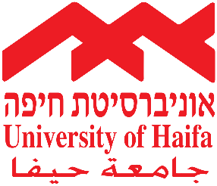
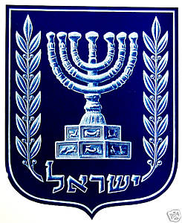

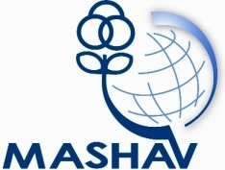

Israel's Agency for International
Development Cooperation
Ministry of Foreign Affairs
The Golda Meir Mashav "Carmel" International Training Center (MCTC)
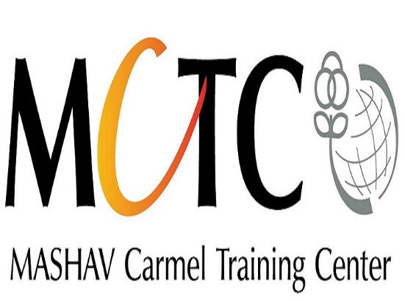

MASHAV - Israel’s Agency for International Development Cooperation

invite professionals
to participate in the
International Course:

“Development of Children: Social Emotional Support and Wellbeing”

January 28 – February 16, 2018
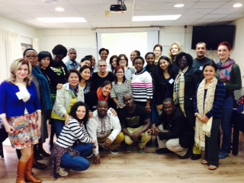
Past participants

About the Course

Background
“Too many children remain excluded from the progress of the past 25 years. The cost of these inequities is paid most immediately – and most tragically – by children themselves. But the long-term impact affects generations to come, undermining the strength of their societies. So addressing these inequities and reducing disparities is not only the right thing to do – honoring the spirit of the Convention on the Rights of the Child – it is also the strategic thing to do, yielding practical gains. As the global community begins to shape – and act on – the post-2015 agenda, dismantling the financial, political, institutional and cultural barriers that stand between children and their rights must be a central priority” (THE STATE OF THE WORLD’S CHILDREN 2015: Executive Summary, UNICEF www.unicef.org/publications/files/SOWC_2015_Summary_and_Tables.pdf).
We know that access to quality early childhood education and care helps narrow the poverty gaps and ensure that children live to their full potential. Early childhood care plays an important role in children's development and provides a valuable support to families with young children. The emotional, social and physical development of young children has a direct effect on their overall development and on the adult they will become. That is why understanding the need to invest in very young children is so important, and to maximize their future well-being.

Aims
In cooperation with the Center for the Development of the Child at the University of Haifa, and in cooperation with OMEP Thessaloniki, and through introductory lectures, professional study visits, observations, workshops, and discussions, participants will be exposed to services and organizations in Israel that support children and their families. Participants will discuss with experts the importance of early detection and intervention for children in need of extra support. They will also gain insight and reflect on the role of the care giver, educator, therapist, social worker, community worker and health care giver in offering support to families and children.

Main Subjects
The following topics will be included in the course:
- Creating a positive environment for children to grow to their potential
- Building resiliency resources in the individual, the family, and the community to enhance awareness of inner strength – through different therapies – art, music, movement, etc.
- Effects of trauma on the child, the family and the community
- Developing coping skills to ease post traumatic syndrome
- Community programs in prevention
- Coordination among community services
- Working in multidisciplinary teams – decision making, negotiating, conflict resolution
- Project planning and writing
- Knowledge and professional exchange among international participants

Application
Application Requirements
This training welcomes men and women with leadership qualities open to new ideas and who see themselves as agents of change. The workshop is open to psychologists, educators, caregivers, NGO trainers, community workers, social workers, health workers, nurses, and university lecturers. Candidates should have academic or equivalent training and experience in working with children and families. Multidisciplinary teams working in the field are encouraged to attend the workshop together. A full command of English is required.

Application forms
Application forms and other information may be obtained at the nearest Israeli mission or at MASHAV’s website: http://mashav.mfa.gov.il/MFA/mashav/Courses/Pages/default.aspx.
Completed application forms, including the medical form, should be sent to the relevant Israeli mission in the respective country no later than November 15, 2017.
One additional copy of the application must be sent to:
Ms. Sarah Wilner at MCTC: sarah@mctc.org.il

General Information
Arrival and Departure
Arrival date: 28.01
Opening date: 29.01
Closing date: 15.02
Departure date: 16.02
Participants must arrive at the training center on the arrival date, and leave on the departure date. Early arrivals/late departures if required, must be arranged by the participants themselves, directly with the center, and must be paid for by the participant him/herself.

Location and Accommodation
MASHAV awards a limited number of scholarships. The scholarship covers the cost of the training program including lectures and field visits, full board accommodation in double rooms (two participants per room), health insurance (see below) and transfers to and from the airport. Airfares and daily allowance are not included in the scholarship.

Health Services
Medical insurance covers medical services and hospitalization in case of emergency. It does not cover the treatment of chronic or serious diseases, specific medications taken by the participant on a regular basis, dental care and eyeglasses. Health authorities recommend that visitors to Israel make sure they have been inoculated against tetanus in the last ten years. Subject to the full binding policy conditions. Participants are responsible for all other expenses.

The course will be held at the Dan Panorama Hotel, situated at Boulevard HaNassi 107 in Haifa. Participants will be accommodated in double rooms (two participants per room).

About MASHAV
MASHAV – Israel’s Agency for International Development Cooperation is dedicated to providing developing countries with the best of Israel’s experience in development and planning. As a member of the family of nations, The State of Israel is committed to fulfilling its responsibility to contribute to the fight against poverty and to the global efforts to achieve sustainable development. MASHAV, representing Israel and its people, focuses its efforts on capacity building, sharing relevant expertise accumulated during Israel's own development experience to empower governments, communities and individuals to improve their own lives.

MASHAV’s approach is to ensure social, economic and environmental sustainable development, and is taking active part in the international community’s process of shaping the Post-2015 Agenda, to define the new set of the global Sustainable Development Goals (SDGs).
MASHAV’s activities focus primarily on areas in which Israel has a competitive advantage, including agriculture and rural development; water resources management; entrepreneurship and innovation; community development; medicine and public health, empowerment of women and education. Professional programs are based on a “train the trainers” approach to institutional and human capacity building, and are conducted both in Israel and abroad. Project development is supported by the seconding of short and long-term experts, as well as on-site interventions. Since its establishment, MASHAV has promoted the centrality of human resource enrichment and institutional capacity building in the development process – an approach which has attained global consensus.
www.mashav.mfa.gov.il
www.facebook.com/MASHAVisrael

About The Center for the Study of Child Development, University of Haifa
The Center for the Study of Child Development at the University of Haifa includes a group of 10 internationally leading senior researchers and their 80 graduate and postdoctoral students, who are devoted to the study of children's development, with a particular emphasis on their emotional health and well-being. The Center’s experts focus on basic science questions regarding the nature of socio-emotional development across the life span and across cultures, and its implications and applications for the lives of children and their families. The Center’s experts have also established a one-year International Master’s Program in Applied Child Development for Developing Countries with the goal of improving the lives of children at risk around the world. It is designed to prepare the next generation of international experts who will focus on pressing questions regarding the nature of child development and how it applies to the lives of children and their families in developing countries. This unique program equips professionals with the knowledge and skills that are necessary when returning to their home countries to affect and influence the well-being of children and their families (for more detail see http://intchilddev.haifa.ac.il/).

About The Golda Meir Mashav "Carmel" International Training Center
The Golda Meir Mashav “Carmel” International Training Center (MCTC) was founded by Golda Meir in Haifa in 1961. MCTC was the first of its kind in the domain of women’s empowerment and since its inception has had a profound influence on both individuals and the policy arena. MCTC endeavors to provide professional women and men from developing countries and transitional societies with the necessary tools for women’s empowerment. It aims to enable women to contribute to the socio-economic development processes of their communities and consequently advance their status. To this end, MCTC conducts training activities, both in Israel and overseas, to advance women’s participation in public life.

To date, over the 54 years of MCTC’s existence, almost 23,000 women and men from over 140 countries have benefited from hundreds of training activities. Today, many of them hold key positions at the local or national level, or within United Nations development agencies.

For further information, please contact:
The Golda Meir Mashav “Carmel” International Training Center (MCTC)
12 David Pinsky street, POB 6111, Haifa 31060, Israel
Tel: +972-4-8375904
Fax: +972-4-8375913
Email: sarah@mctc.org.il
Website: www.mctc.org.il

