Diploma in
Public Management
AGCID – Univ. de Chile

Table of Contents
Contents
Table of Contents 1
Identification of parties involved 2
Introduction 3
Presentation of the program 0
Focus of the Program 4
General Objectives 1
Directed at 1
Selection 2
Academic Program 2
Training structure 5
Methodology 7
Additional information about the Methodology of the Diploma Program 8
Evaluation and attendance 9
Duration and schedule 10
Logistical aspects 11
Portfolio per student 12
Final Report and Evaluation of studies 12
Benefits 12

Identification of parties involved

Introduction

The Modernization process of the State implies the intervention of new Public Management tools, so that governments will have participants with highly efficient skills and capacities.
Today, public entities are involved in meeting ever more demanding citizens’ requirements. In order to do this, public officers or civil servants need to learn new styles of organization in their work, so that the activities they perform are translated into optimal results for the population.
The implication of developing modern internal processes is accompanied by new public management systems that integrate Information Technology and Process Redesign tools that must be focused on and created with and for the user through citizen participation mechanisms.
Transforming the State’s work methods is a complex task, but it is undoubtedly feasible. To this end, the skills of decision-makers in internal processes should be strengthened, oriented towards results and generating appropriate incentives allowing them to create and innovate within the complexity of public institutions.
For this, it is necessary to dispense with management paradigms in the public sector. The thinning out of bureaucracy, must be translated into the efficient use of available human and economic resources, in addition to having clarity in new approaches to governance, social problems, territorial public policies, gender issues, and sustainability without neglecting the probity and ethics that must prevail in the complexity of State institutions.
Managing the State is a task that includes new mechanisms of participation among diverse actors. Today, the ability to govern lies in the capacity for innovation and organization of employees in public institutions.
To acquire these capacities, it is necessary to develop cognitive skills in addition to integrating management tools into their activities, which allow them to have better control of the actions that they must take into account when making decisions.
To meet these needs, the Industrial Engineering Department (DII) of the Universidad de Chile, recognized as a leader in the training of professionals involved in directing the public sector, through its Public Systems Center, has designed the Postgraduate Diploma in Public Management program, which, since 2003, has provided tools to decision-makers in diverse public sector institutions in Chile and Latin America, meeting the New Public Management requirements.

Presentation of the program

The Industrial Engineering Department officially created the Public Systems Center (CSP) in 2010 with the mission of integrating engineering and management approaches with the design and implementation of public policies, with the aim of making a relevant contribution to the area of reform and modernization of the State in Chile and Latin America.
At the moment, the Academic Director of the CSP is the professor, Pablo González. The objectives of the Center are the following:
- Ensure that the Industrial Engineering Department is a central reference point for the public institutions of Chile and Latin American States in relation to the solution of intensive problems in management, engineering, and innovation and which, also, generates a significant impact on society.
- To develop research, in the medium to long term, applied in transversal services of the State, particularly those related to the management of people, public acquisitions, and modernization of the management of institutions.
Mission
To integrate approaches for the design and implementation of public policies, in order to make a relevant contribution to the reform and modernization of the State in Chile and Latin America.
- To foster the development of public innovation systems and support implementation processes, especially in those public services that are directly related to citizens, and understanding decentralization as a key element of the country's development.
- Contribute to the design, implementation, and evaluation of public policies, which will improve people’s sense of agency, having an impact on their human development, mainly in the health and education sectors.
- Build capacities in the State and in civil society so that organizations and programs are managed with excellence, by offering a wide range of Diplomas and Courses in key areas.
The Center focuses its efforts on the development of research, consulting, teaching, and extension activities with and in organizations such as:
- National, regional, and local public institutions.
- Ministries and public services.
- State Corporations.
- International Organizations.
- Foundations and NGOs.

The Diploma in Public Management, which arose as a complementary program to the Master’s degree in Management and Public Policies (the possibility of continuing postgraduate studies is granted once the diploma course has been completed) has been given by the Industrial Engineering Department since the year 2003. The focus of the program is mainly for government professionals who wish to acquire tools and develop skills in public management. In its 14 years with more than 30 uninterrupted versions, it has trained more than 900 professionals from the public sector (95%) NGOs and international organizations (3%) and private sector (2%), who have evaluated the development of contents and associated activities as excellent.

This program has been offered in versions open to the public and in closed versions for public institutions such as: SUBDERE, the Comptroller General of the Republic, the Superintendence of Electricity and Fuels, the Municipality of La Granja, and the Municipal Corporation of Peñalolén.
The versions are detailed below:

Past Experiences of the Public Management Diploma Program
No. | Diploma/Major | Public/Private Organism | Date of execution | Reference
 | Postgraduate Diploma in Public Management. | Postgraduate School Mathematics and Physical Sciences School Universidad de Chile | Second Semester of 2003 | Postgraduate School FCFM Richard Weber rweber@dii.uchile.cl  +56 2 26712799
 | Postgraduate Diploma in Public Management. | Postgraduate School Mathematics and Physical Sciences School Universidad de Chile | Second Semester of 2004 | Postgraduate School FCFM Richard Weber rweber@dii.uchile.cl  +56 2 26712799
 | Postgraduate Diploma in Public Management. | Postgraduate School Mathematics and Physical Sciences School Universidad de Chile | Second Semester of 2005 | Postgraduate School FCFM Richard Weber rweber@dii.uchile.cl  +56 2 26712799
 | Postgraduate Diploma in Public Management. | Postgraduate School Mathematics and Physical Sciences School Universidad de Chile | Second Semester of 2006 | Postgraduate School FCFM Richard Weber rweber@dii.uchile.cl  +56 2 26712799
 | Postgraduate Diploma in Public Management. | Postgraduate School Mathematics and Physical Sciences School Universidad de Chile | Second Semester of 2007 | Postgraduate School FCFM Richard Weber rweber@dii.uchile.cl  +56 2 26712799
 | Postgraduate Diploma in Public Management. | Postgraduate School Mathematics and Physical Sciences School Universidad de Chile | First Semester of 2008 | Postgraduate School FCFM Richard Weber rweber@dii.uchile.cl  +56 2 26712799
 | Postgraduate Diploma in Public Management, with major in territorial management. | Municipal and Regional  Training Academy SUBDERE | Second Semester of 2008 | Edgar Rebolledo Toro  226 36 36 51  edgar.rebolledo@subdere.gov.cl
 | Postgraduate Diploma in Public Management. | Superintendence of Electricity and Fuels | Second Semester of 2008 | Christián Miño Contreras  227565180  cmino@sec.cl
 | Postgraduate Diploma in Public Management. | Postgraduate School Mathematics and Physical Sciences School Universidad de Chile | Second Semester of 2009 | Postgraduate School FCFM Richard Weber rweber@dii.uchile.cl  +56 2 26712799
 | Postgraduate Diploma in Public Management. | Superintendence of Electricity and Fuels | Second Semester of 2009 | Christián Miño Contreras  227565180  cmino@sec.cl
 | Postgraduate Diploma in Public Management. | Postgraduate School Mathematics and Physical Sciences School Universidad de Chile | First Semester of 2010 | Postgraduate School FCFM Richard Weber rweber@dii.uchile.cl  +56 2 26712799
 | Postgraduate Diploma in Public Management. | Postgraduate School Mathematics and Physical Sciences School Universidad de Chile | Second Semester of 2010 | Postgraduate School FCFM Richard Weber rweber@dii.uchile.cl  +56 2 26712799
 | Postgraduate Diploma in Public Management. | Superintendence of Electricity and Fuels | First Semester of 2010 | Christián Miño Contreras  227565180  cmino@sec.cl
 | Postgraduate Diploma in Public Management (Strategic Educational Management version) | Municipal Corporation of Peñalolén | Second Semester of 2010 | Paula Arriagada  Training Director  229397092  parriagada@cormup.cl
 | Postgraduate Diploma in Public Management. | Postgraduate School Mathematics and Physical Sciences School Universidad de Chile | First Semester of 2011 | Postgraduate School FCFM Richard Weber rweber@dii.uchile.cl  +56 2 26712799
 | Postgraduate Diploma in Public Management (Strategic Educational Management version ) | Department of Education, Municipality of La Granja | First Semester of 2011 | Grettyis Bravo  Capacitaciones  grettys.bravo@gmail.com  225503700
 | Postgraduate Diploma in Public Management. | Postgraduate School Mathematics and Physical Sciences School Universidad de Chile | First Semester of 2012 | Postgraduate School FCFM Richard Weber rweber@dii.uchile.cl  +56 2 26712799
 | Postgraduate Diploma in Public Management. | Closed version Comptroller General of the Republic | First Semester of 2012 | Nicolás Pozo  Training dept.  npozova@contraloria.cl  24021583
 | Postgraduate Diploma in Public Management. | Postgraduate School Mathematics and Physical Sciences School Universidad de Chile | Second Semester of 2012 | Postgraduate School FCFM Richard Weber rweber@dii.uchile.cl  +56 2 26712799
 | Postgraduate Diploma in Public Management. | Postgraduate School Mathematics and Physical Sciences School Universidad de Chile | First Semester of 2013 | Postgraduate School FCFM Richard Weber rweber@dii.uchile.cl  +56 2 26712799
 | Postgraduate Diploma in Public Management. | Closed version Comptroller General of the Republic | Second Semester of 2013 | Nicolás Pozo  Training Dept.  npozova@contraloria.cl  24021583
 | Postgraduate Diploma in Public Management. | Postgraduate School Mathematics and Physical Sciences School Universidad de Chile | Second Semester of 2013 | Postgraduate School FCFM Richard Weber rweber@dii.uchile.cl  +56 2 26712799
 | Postgraduate Diploma in Public Management. | Postgraduate School Mathematics and Physical Sciences School Universidad de Chile | First Semester of 2014 | Postgraduate School FCFM Richard Weber rweber@dii.uchile.cl  +56 2 26712799
 | Postgraduate Diploma in Public Management. | Postgraduate School Mathematics and Physical Sciences School Universidad de Chile | Second Semester of 2014 | Postgraduate School FCFM Richard Weber rweber@dii.uchile.cl  +56 2 26712799
 | Postgraduate Diploma in Public Management. | Postgraduate School Mathematics and Physical Sciences School Universidad de Chile | First Semester of 2015 | Postgraduate School FCFM Richard Weber rweber@dii.uchile.cl  +56 2 26712799
 | Postgraduate Diploma in Public Management. | Postgraduate School Mathematics and Physical Sciences School Universidad de Chile | Second Semester of 2015 | Postgraduate School FCFM Richard Weber rweber@dii.uchile.cl  +56 2 26712799
 | Postgraduate Diploma in Public Management. | Postgraduate School Mathematics and Physical Sciences School Universidad de Chile | First Semester of 2015 | Postgraduate School FCFM Richard Weber rweber@dii.uchile.cl  +56 2 26712799
 | Postgraduate Diploma in Public Management. | Postgraduate School Mathematics and Physical Sciences School Universidad de Chile | Second Semester of 2016 | Postgraduate School FCFM Richard Weber rweber@dii.uchile.cl  +56 2 26712799
 | Postgraduate Diploma in Senior Public Management | Closed version Santiago ACADEMIA SUBDERE | October- December 2016 | Edgar Rebolledo Toro  226 36 36 51  edgar.rebolledo@subdere.gov.cl
 | Postgraduate Diploma in Senior Public Management | Closed version Concepción ACADEMIA SUBDERE | October- December 2016 | Edgar Rebolledo Toro  226 36 36 51  edgar.rebolledo@subdere.gov.cl
 | Postgraduate Diploma in Public Management. | Postgraduate School Mathematics and Physical Sciences School Universidad de Chile | First Semester of 2017 | Postgraduate School FCFM Richard Weber rweber@dii.uchile.cl  +56 2 26712799
 | Postgraduate Diploma in Public Management. | Universidad de El Salvador-Inter-American Development Bank (IDB) | August 2017 | Universidad de El Salvador  Gracia Ivonne Bonilla  gracia.bonilla@ues.edu.sv  (503) 2521-0225
 | Postgraduate Diploma in Senior Public Management | Closed version Concepción ACADEMIA SUBDERE | September- november 2017 | Guido de la Torre  226 36 36 04  guido.delatorre@subdere.gov.cl
 | Postgraduate Diploma in Senior Public Management | Closed version Concepción ACADEMIA SUBDERE | October- December 2017 | Guido de la Torre  226 36 36 04  guido.delatorre@subdere.gov.cl
 | Postgraduate Diploma in Public Management. | Chilean International Cooperation Agency (AGCID) | November 2017 | Pablo García  56 2 2827 5785  pgarcia@agci.gob.cl

Focus of the Program

The Industrial Engineering Department has developed 3 training areas regarding Public Management issues a) Economics and Public Policies, b) Management Skills c) Public Management. On the other hand, new thematic areas have been incorporated regarding the current processes that Chile requires: Public innovation and Decentralization
Therefore, the proposed program draws on this experience and its focus includes the following: firstly, participants will be able to learn about and discuss topics related to the current debate on paradigm shifts in Management, and priority will be given to studying the skills needed to comprehend and act effectively in a globalized environment where learning to learn and the formation of systemic networks require new skills to deal with the new realities.
The program will be structured on the basis of a balance between modern theoretical approaches and the practical analysis of new concepts and paradigms in public management, with emphasis on the strengthening of professional skills necessary to tackle the challenges of institutional modernization and to fully understand the implications of the processes of change, the incorporation of technologies, and the ongoing redesign of work practices and processes.

The above is related to the notions of strategic thinking and value creation in the public sector, concepts of democratic governance, and modernization of public management, innovations in information technology, and tools for management control and redesign of State processes.
During the program, research will be done and the design of structures, work processes, management methods and techniques, and skills necessary to guarantee both the personal development of the participants and the generation of support networks will be covered, as well as the students’ potential capacity of becoming managers of change and innovation within their own institution.

General Objectives
Provide participants with a broad and analytical vision of concepts, models, practices, and recurrent phenomena in public organizations, contributing to obtaining management skills and strengthening their capacities to formulate, lead, and manage the strategies that their institution promotes for institutional development and the modernization process, currently underway.

Directed at

- 10 professionals from the Republic of South Africa’s Government, who have at least 3 years of experience in Government Management.
- 12 professional public policy leaders from 6 countries in the Central American Region, who demonstrate at least 3 years of experience in Government Management.
- 6 professional public policy leaders from countries concurrent to the Chilean Embassies in Jamaica, Trinidad, and Tobago and Guyana.

Application requirements

- Notarized copy of university degree (of a degree program at least 8 semesters long)
- Copy of Curriculum Vitae
- Photocopy of Passport
- Certification of English language (the Embassy of Chile may certify)
- Application Form to AGCID
- Simple medical certificate that indicates appropriate physical and mental health for participating in the Diploma program.
- Letter of recommendation and support from the institution where applicant works.
THESE DOCUMENTS SHALL BE PRESENTED IN THE CHILEAN EMBASSY OF THE INVITED COUNTRY

Selection

The selection shall be done through the Chilean embassies in the following countries:
- Republic of South Africa, 10 openings
- Republic of Guatemala, 2 openings
- Republic of El Salvador, 2 openings
- Republic of Honduras, 2 openings
- Republic of Nicaragua, 2 openings
- Republic of Costa Rica, 2 openings
- Republic of Panamá, 2 openings
- CARICOM, 6 openings (2 from each Chilean Embassy in Jamaica, Trinidad and Tobago, and Guyana)
Thus, in order to achieve an adequate level of female participation in the program, female candidates will be favored, seeking to ensure that at least 40% of participants are female.

Academic Program

Diploma program with presential particiation of 120 chronological hours with the following units:
  - Introduction to Public Management
The general purpose is to identify and deepen general concepts of public management, through an exposition on Complex Systems Theory, which implies an analysis of the current situation of public management in Latin America and South Africa, in addition to an analysis of the processes of change in their State apparatuses.
Likewise, the topics related to the processes of change and institutional transformation are discussed in detail under te focus of Change Management and the experience of State Reform and modernization of public management in Chile and participating countries.
This unit includes the following subjects:
- Complex Systems and Public Management.
- Management of Change.
- Public Management
- Modernization of the State
- Management Evaluation
- Implementation of Policies
- The importance of Leadership, organizational climate
- Implementation of Policies and Public Marketing
- Innovation in the public sector
- Sustainable Resource Engine
- Successful experiences
Redesign of Processes and Management of Information Technologies
The course is aimed at allowing participants to understand, model, analyze, design, and apply (redesign) methodologies and modern process tools. It will enable students to use the necessary knowledge to understand information technologies as a strategic element in public management in accordance with the new requirements demanded by society regarding the knowledge and development of integrated information systems, and the recent concept of "Virtual State”, involving the most direct relationship with public citizens-users.
This unit is divided into two sub-units: "Design of Processes" and "Design and Management of Information Technologies".
Design of Processes
- Process Methodologies
- Modern process tools
- Process surveys (BPM and use of Bizagi Software)
- Quantitative analysis of processes
- Diagnosis and qualitative analysis of processes
- Introduction to Process Redesign
- Ongoing improvement.
- Redesign techniques and patterns
- Practical redesign workshop
- Case presentation. Invited
Design and Management of Information Technologies
- Conceptual framework: Information Technologies and Public Management
- Synoptic review of IT in the public sector
- Evolution of IT
- New paradigms in IT management
- IT and its use by the state
- Concept and applications of ICT architectures.
- Technological Public Policies
- ICT project management
- IT contracting
- Access to public information
- Regulatory framework
- Open Gov and Open Data
- Transparency and Participation
  - Management and Management Control Tools
The fundamentals of public management include the concepts associated with various management tools, including strategic planning, business model in Public Management, project management, and Management Control models, perceived as important resources to evaluate the overall performance of the institution and each of its areas. For example, Management Control incorporates techniques such as the Balanced Scorecard widely applied in the Chilean public sector, in order to ensure that the organization implements and measures its strategies and, at the same time, enure that the skills and conduct of its participants effectively contribute to the achievement of its objectives.
This unit includes the following subjects:
- Modernization and Reform of the State, its evolution in time and influential currents of thought in that process
- Business Model: study of the creation of value and its incidence in the generation of competitive advantages, analysis of business models of public and private entities
- Value chain: distinction between primary and support activities, links in the value chain
- Porter's analysis, inspiring currents of the model and their limitations
- Strategic Planning. Differentiation between inputs and outputs, processes underlying planning and their work sequence. Mission, vision, strategic objectives. Analysis of the strategic planning of public and private entities. SWOT Analysis and its consistency with strategic objectives
- Management indicators, their contribution as a control mechanism to the achievement of goals. Scope and control dimension
- Risk Analysis. Historical evolution of the risk analysis from internal control, its redefinition to the creation of the COSO II. Analysis of emblematic cases without the respective identification and/or risk management. Balanced Scorecard (CMI)
- Government Management and Control System. Objectives, strategic definitions, evaluation of programs and institutions, presentation of programs to the budget, Comprehensive Management Balance Sheet (BGI), incentive mechanisms for remunerations, modernization fund for public management
  - Leadership skills
The main objective of this unit is to provide distinctions and theoretical models in order to comprehend the phenomena involved in management, increasing the skills and abilities of the participants to lead and motivate people, placing special emphasis on the processes of Organizational Leadership, Teamwork, and Communication Skills for Conflict Management.
This unit includes the following subjects:
- The main skills of the leader: Diagnosis, Flexibility, and Performance Management.
- The development stages of participants.
- Leadership styles.
- Adaptation of leadership styles to the development stages of participants.
- The stages of group development.
- The properties of high performance teams.
- The contribution of the personal profile to teamwork.
- Evaluation of the communication styles used in situations of conflict.
  - Organizational analysis workshop
Through group work and a highly specialized methodology and designed by the academics of this program, a case study will be developed throughout the training process, which allows to apply the subjects of the units to the concrete experience of their Institutions. A brief diagnosis will be made and a modernization strategy will be designed with a focus on institutional priorities.
- In b-learning mode, during the process there will be accompaniment of the teaching team of the unit, through presential meetings, video conferences, forums or other means of communication.
- Work will be done on a case study with information previously requested from the participants, from the public institutions where they work, delivering the methodology previously.
- The result of the work must finally be presented to a panel composed of professors of the program and the rest of the students.

Training structure

The Diploma in Public Management program integrates two parallel and interdependent dimensions of learning: one that can be seen as individual learning, that is, as an expansion of the individual participant’s capacities for action; and another that corresponds to "network learning", as it improves the manifestation of individual skills through collective collaborative work among the various participants (with whom we intend, from a methodological perspective, to incorporate effective teamwork and project management practices), work that will be enhanced with the online platform to generate and support teamwork from a distance.
- Individual learning dimension.
An Academic Program, or cognitive development, which includes the following units:
1. Introduction to Public Management.
2. Design of processes and management of information technologies
3. Tools for management and control of management
4. Management skills
5. Institutional Case Study Workshop

- “Network Learning” dimension
The dimensions of network learning do not translate into specific programs, as in the case of individual learning, but rather correspond to the results expected to be achieved by the interaction between students through the different activities that make up the units and the use of the available technology. Specifically, it intends to achieve:
- The socialization, incorporation and appropriation of the process of State Reform and Modernization of Public Management in their countries of origin.
- The effective incorporation of conceptual frameworks, distinctions, tools and management devices applied to the concrete situation of the participants.
- The strengthening of networks and trust in the participating professionals: among them, in the process of modernization of public management and in themselves.
- Learning, through the practical use, of the usefulness of information technologies to work in teams at a distance. The strong use of the online platform and other complementary technologies during the development of the Diploma program will allow the students to get to know these tools, see their usefulness, and to motivate them to use them for their own work.
In this holistic concept of learning, the participating "student" plays a central role. In this regard, the central protagonist of the process is the participant himself/herself, who is responsible for optimizing the effectiveness, efficiency, and well-being of the process. For this reason it is fundamental to understand the learning project as a personal project and "in the action", that is, a project which design and execution is closely linked to the identification and gradual resolution of urgent and contingent problems of their work as a manager and/or professional in the organization in which they perform.

Methodology

The Diploma program will be held in a presential manner, where the participants will attend classes in person and they will also have to develop activities outside the class schedule, for which they will have an online platform and a support team at their disposal which will act as a help desk and support for teaching coordination and collaboration, via email, forum and, if necessary, in personal meetings and through videoconference.

  - Presential methodology:
- Lectures with the support of audiovisual presentations.
- Case analysis and general discussion.
- Individual exercises to be developed in comprehension and application classes.
- Practical application workshops and work to be developed by the student in his/her place of work.
- Intermediate evaluations by unit, both infividually and in a group carried out in class.
- Recommended reading of study texts and related publications.
In addition, if the student deems it pertinent, the contents of the program will be supported and backed up by the use of information technologies, synthesized in an online platform developed by the Mathematics and Physical Sciences School of the Universidad de Chile called u-courses (www.u-cursos.cl). This platform is accessible by internet and has an easy navigation system, which integrates the following functionalities:
- Teaching Material: This is a virtual library of documentation (in ppt, pdf, and Word formats) available to all participants at the time they require it;
- Communication and interaction tools among participants, such as calendar, mailbox, forum, and chat;
- Reception of students’ homework: a space where participants can upload a file corresponding to homework set by the teaching team up to a certain date;
- Record of partial notes: a space where the teaching team uploads the results of the evaluations so that the participants can see their own grades and the statistics of the global grades;
- Usage statistics: allows viewing the level of activity of each user in the system.

Figure 1: U-Courses pages
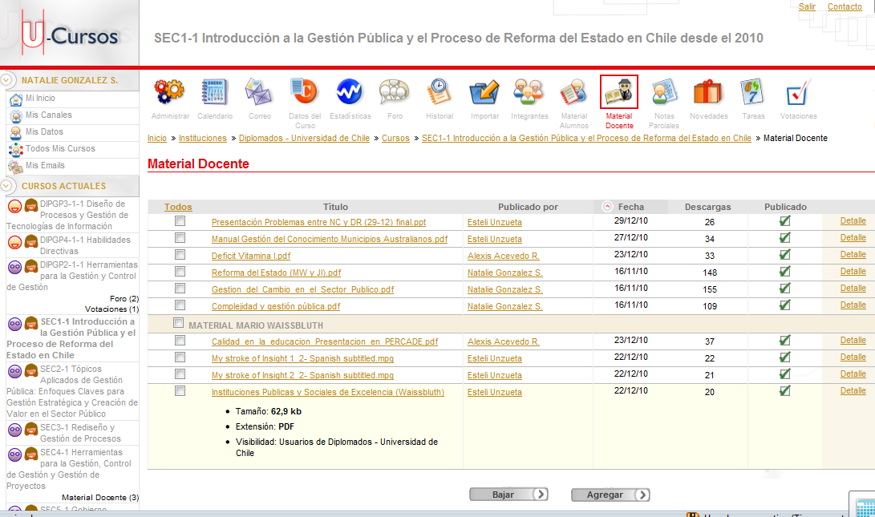
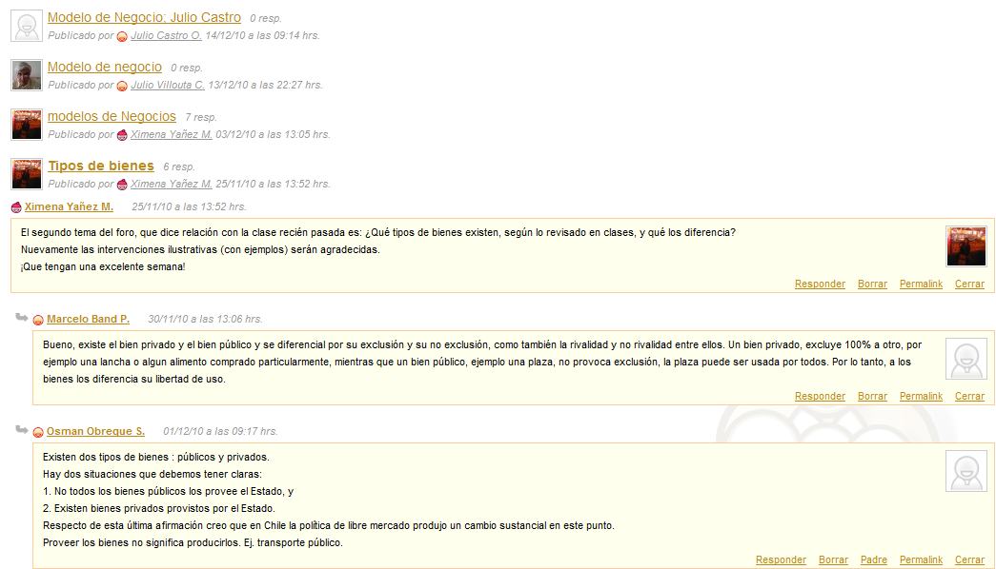

Additional information about the Methodology of the Diploma Program

The program will be implemented in person (120 hours), but the participants will also have to develop activities outside the class schedule, for which they will have the aforementioned online platform and a team of assistants (tutors) at their disposal who will act as a Help desk and provide support for teacher coordination and support, via e-mail, forum, and, in some cases, personal meetings.
On the other hand, and considering its academic value, the methodological approach stands out for granting the participants distinctive opportunities such as:
- Learning: acquisition of general and specific knowledge about diverse management approaches, managerial skills, basic concepts about the role of the State and its institutions, among others.
- Capacities: acquisition of skills to manage the varied and complex challenges faced by public entities, in a constantly changing environment where information management and the use of useful technological tools facilitate professional practice in this society of information and make it possible to strengthen relational skills.
- Networks: participation in networks and exchange of ideas, experiences, and visions about common problems in a virtual environment that will remain active as long as members require it.
- Remote Interaction: The didactic methodology of the Program will also be based on the pedagogical model of virtual training through a telematic environment: the online platform, which allows overcoming the barriers of space and time through computers and communication networks, facilitating the individualized and interactive contact between all members of the learning community.
The courses and our educational methodology facilitate deep, comfortable, flexible, and ongoing learning. They are designed with the objective that the participants, during the development of the program, achieve:
- Working in a network and increasing their knowledge, skills, and competencies.
- Adapting to professional changes and incorporating innovation into their professional practice.
- Growing and progressing personally and increasing their professional skills.
- Enjoying a broad worldview, with the ability to create, innovate, and solve problems using multiple resources.

Evaluation and attendance

- The minimum requirements for passing are: 80% minimum attendance to the classes and a final grade above 4.0 as a weighted average of the units developed.
- Likewise, whoever has not completed all the units of the program, will not obtain the corresponding diploma; however, they will be given a certificate with the grades of the units passed. These certifications will include the grade point average and attendance rate.
Grade Point Average of Courses
- Depending on the methodology of each unit, a space of time will be allocated for the execution of written tests and/or practical work.

Evaluation of prior and final knowledge

- Delta of learning: In order to understand and determine the learning of each of the participants, a diagnostic test will be applied at the beginning of the program and a test will be given on the final knowledge of the program, to see the progress made by the students. This evaluation will be integrated by concepts related to each of the units of the Diploma program, as well as a section on the expectations of the course and its final perceptions.
- The time of personal dedication of each student, outside the classroom, is estimated to be at least 5 hours per week. This time of personal dedication is fundamental to achieve a better use of the academic program, which requires the permanent support of the employers of the participants.

Duration and schedule

The Diploma Program consists of 120 presential academic hours. These hours shall take place during 20 sessions (in 3 weeks time) of 8 presential hours from 9:00 a.m. to 6:00 p.m. from November 5 to 23 2018, at the facilities of the Universidad de Chile. There will be morning and afternoon coffee service, plus one free hour for lunch.
1° Week
DATE | 05-nov | 06-nov | 07-nov | 08-nov | 09-nov
HOUR | MONDAY | TUESDAY | WEDNESDAY | THURSDAY | FRIDAY
9:00-10:00 | Opening ceremony | Introduction to Public Management | Management Control Tools | Introduction to Public Management | Organizational analysis workshop
10:00-10:30
11:00-11:15 | Coffee Break
11:15-12:00 | Leadership skills | Introduction to Public Management | Management Control Tools | Introduction to Public Management | Organizational analysis workshop
12:00-13:00
13:00-14:00 | Lunch
14:00-15:00 | Leadership skills | Introduction to Public Management | Management Control Tools | Introduction to Public Management | Organizational analysis workshop
15:00-16:00
16:00-16:15 | Coffee Break
16:15-17:00 | Leadership skills | Introduction to Public Management | Management Control Tools | Introduction to Public Management | Organizational analysis workshop
17:00-18:00
18:00-19:00 | Leadership skills
19:00-20:00

2° Week
DATE | 12-nov | 13-nov | 14-nov | 15-nov | 16-nov
HOUR | MONDAY | TUESDAY | WEDNESDAY | THURSDAY | FRIDAY
9:00-10:00 | Leadership skills | Management Control Tools | IT Management | Management Control Tools | Redesign of Processes
10:00-10:30
11:00-11:15 | Coffee Break
11:15-12:00 | Leadership skills | Management Control Tools | IT Management | Management Control Tools | Redesign of Processes
12:00-13:00
13:00-14:00 | Lunch
14:00-15:00 | Leadership skills | Management Control Tools | IT Management | Management Control Tools | Organizational analysis workshop
15:00-16:00
16:00-16:15 | Coffee Break
16:15-17:00 | Leadership skills | Management Control Tools | IT Management | Management Control Tools | Organizational analysis workshop
17:00-18:00

3° Week
DATE | 19-nov | 20-nov | 21-nov | 22-nov | 23-nov
HOUR | MONDAY | TUESDAY | WEDNESDAY | THURSDAY | FRIDAY
9:00-10:00 | Leadership skills | Management Control Tools | IT Management | Redesign of Processes | Organizational analysis workshop
10:00-10:30
11:00-11:15 | Coffee Break
11:15-12:00 | Leadership skills | Management Control Tools | IT Management | Redesign of Processes | Organizational analysis workshop
12:00-13:00
13:00-14:00 | Lunch
14:00-15:00 | Leadership skills | Management Control Tools | IT Management | Redesign of Processes | Organizational analysis workshop
15:00-16:00
16:00-16:15 | Coffee Break
16:15-17:00 | Leadership skills | Management Control Tools | Redesign of Processes | Redesign of Processes | Organizational analysis workshop
17:00-18:00
18:00-19:00 |  |  |  |  | Closing Ceremony
19:00-20:00

Validation of the diploma with the Management and Public Policies Masters degree program in the Industrial Engineering Department of the Universidad de Chile
All participants who pass this Diploma program and are interested in getting a Masters degree in the field, will be able to validate the units taken with elective units from the Management and Public Policies Master’s degree program in the Industrial Engineering Department of the Universidad de Chile. This validation can be used up to 2 years after having passed the Diploma program.

Logistical aspects
The courses and units of the program will be carried out at the facilities of the Universidad de Chile.
In addition, the University will deliver to each participant a notebook of notes, a pen, and printed teaching material from the University.

Portfolio per student
For each student a record will be kept of their attendance, their work and evaluations with the corresponding papers and grades obtained will be filed. All this information will be delivered to AGCID in electronic format and will also be put on the online platform, which each participant can continue to access after the course has ended.

Final Report and Evaluation of studies
The Industrial Engineering Department of Universidad de Chile’s Mathematics and Physical Sciences School will grant a Diploma and a certificate of approval and grades to those who have completed the program’s units and who have passed the corresponding work and Evaluations.
It should be noted that the Minimum Passing Requirements are: minimum attendance of 80% of sessions per work area.
The purpose of establishing certain minimum passing requirements is associated with the idea of commitment on the part of each participant. From this point of view, we respond to an institution that invests in the training of its professionals, and therefore, the results must be evaluated based on the impact that our actions can provoke in it.
On the other hand, the University will deliver to the student a final Evaluation Report of the program containing at least: a) Attendance List, b) Final grade obtained and, if the institution requires it, certificates of approval and Diplomas granted, among others.

Benefits

- AGCID will pay for the round trip ticket from the capital of your country to Santiago de Chile and back.
- Health, life and accident insurance for the duration of the program.
- Lodging for the duration of the program.
- Allowance of $ 440,000 Chilean pesos for food, transportation.

http://www.sistemaspublicos.cl
Ph.D. in Economy (1996) and M. Phil. (1990), University of Cambridge. M.A. in Economy and Social Sciences (1988), Degree in Commercial Engineering (1988) and Economy (1986), Pontificia Universidad Católica de Chile, Santiago.

